**LOGIC GATES SIMULATOR SYSTEMS**

**A SEMINAR PAPER BY**

**IGBOEKWULUSI FRANKLIN CHINEDU**

**2017364022**

**DEPARTMENT OF ELECTRONIC AND COMPUTER ENGINEERING**

**NNAMDI AZIKIWE UNIVERSITY, AWKA**

**JANUARY 2023.**

**LOGIC GATES SIMULATOR SYSTEMS**

**A SEMINAR PAPER BY**

**IGBOEKWULUSI FRANKLIN CHINEDU**

**2017364022**

**IN PARTIAL FULFILMENT OF THE REQUIREMENTS FOR THE AWARD OF BACHELOR IN ENGINEERING (B.ENG)**

**DEPARTMENT OF ELECTRONIC AND COMPUTER ENGINEERING NNAMDI AZIKIWE UNIVERSITY, AWKA**

**JANUARY 2023.**

# **CERTIFICATION PAGE**

The seminar work “Logic gates Simulator Systems” was carried out by me under the supervision Engr. Dr. Kenneth Akpado and has not been submitted in part or full to this university or any other institutions for the award of a degree.

Igboekwulusi Franklin Chinedu Date

# **APPROVAL PAGE**

This is to certify that this seminar paper written by ”Igboekwulusi Franklin Chinedu” with registration number 2017364022 has been supervised and approved by the Department of Electronics and Computer Engineering, Nnamdi Azikiwe University Awka by:

Engr. Dr. Kenneth Akpado Date

(Supervisor)

Engr. Dr. Kenneth Akpado Date

HOD, ECE Department

**DEDICATION**

I dedicate this report to the Almighty God for his faithfulness and grace upon my life and my family for their maximum support in my academic pursuits.

**ACKNOWLEDGEMENT**

My profound gratitude goes to God almighty and my wonderful parents for always being there for me.

My special thanks go to my supervisor Engr. Dr. Kenneth Akpado, the H.O.D of the department Engr. Dr. Kenneth Akpado and all the wonderful lecturers in the department of electronics and computer engineering for their intensive lectures and maximum support both academically and morally

I would also like to acknowledge all the lecturers in Electronics and computer Engineering and Electrical Engineering whose lecturing since my first year gave me the adequate knowledge needed to carry out this seminar.

And also, I would also like to acknowledge all the non-academic staff and technologist(s) of The Electronics and Computer Engineering department for their support especially Engr. Okafor Tyndale and Engr. Asogwa Ekene for their assistance.

**ABSTRACT**

Logic gate simulator systems are computer programs that allow users to design and simulate digital logic circuits. These systems provide a graphical user interface (GUI) for designing and simulating logic circuits, allowing users to create, edit, and debug their designs. The GUI typically includes a library of logic gates, such as AND, OR, NOT, NAND, NOR, XOR, and XNOR gates. Users can also add custom components to the library. The simulator then simulates the circuit's behavior in real-time and provides visual feedback on the circuit's operation. This allows users to quickly identify errors in their designs and make corrections before committing them to hardware. Logic gate simulator systems are used by engineers in the design of digital logic circuits for embedded systems and other applications.

**Table of content Page**

Title page ii

Certification page iii

Approval page iv

Dedication v

Acknowledgement vi

Abstract vii

Table of content viii

List of figures ix

SECTION ONE: INTRODUCTION 1

* 1. Background of study 1

1.1.1 Brief history of logic gates simulators 2

SECTION TWO: DESIGN, TYPES AND EXAMPLES OF LOGIC GATE SIMULATOR SYSTEMS 4

2.1 Design of logic gate simulators systems 4

2.2 Types of logic gate simulator systems 5

2.3 Examples of logic gate simulator systems 5

SECTION THREE: SOCIETAL IMPORTANCE AND REAL WORLD APPLICATIONS OF LOGIG GATE SIMULATOR SYSTEMS 9

3.1 Societal importance of logic gate simulator systems 9

3.2 Real world applications of logic gate simulator systems 11

SECTION FOUR: CONCLUSION 12

REFRENCES 13

**LIST OF FIGURES**

Figure1: Diagram showing a design of a logic gate simulator system. Page 4

Figure 2: Diagram showing the different types of digital logic gates Page 6

Figure 3: Screen shot of Logisim 2.7.0 Page 7

Figure 4: Screen shot of CircuitVerse

**SECTION ONE: INTRODUCTION**

* 1. **Background** **of** **study**

Logic Gate Simulator is an open-source tool for experimenting with and learning about logic gates. The simulator tool was originally designed for CIS students at [South Puget Sound Community College](http://www.spscc.ctc.edu/) but is free for anyone to use and modify under the GPL(General Public License) v3. Logic Gate Simulator is written in C#/WPF using .NET 4 [1]

Logic gate simulator systems are computer programs that allow users to simulate the behavior of logic gates. They are used to design and test digital circuits, and can be used to teach basic logic concepts. Logic gate simulators typically provide a graphical user interface (GUI) that allows users to create and manipulate logic gates, as well as simulate their behavior. The GUI usually includes a library of logic gates, which can be dragged and dropped onto the workspace. The user can then connect the gates together to form a circuit, and then run simulations to see how the circuit behaves under different input conditions.

* + 1. **Brief History of Logic Gate Simulators**  
       Logic gate simulators have been around since the early days of computing. The first logic gate simulator was developed in the 1950s by IBM for use in their computers. This simulator was used to test and debug logic circuits before they were implemented in hardware.

In the 1970s, the first commercial logic gate simulators were released. These simulators allowed users to design and simulate digital circuits on their personal computers. They also allowed users to create custom logic gates and simulate them in real-time.

Since then, many different types of logic gate simulators have been developed, including those for educational purposes, professional engineering applications, and even gaming applications. Today, there are a variety of free and commercial logic gate simulators available for use on both desktop and mobile devices.[2]

**SECTION TWO: DESIGN, TYPES AND EXAMPLES OF LOGIC GATE SIMULATOR SYSTEMS**

**2.1 Design of a logic gate simulator**  
A logic gate simulator is a computer program that allows users to simulate the behavior of logic gates. It is designed to help students and engineers understand how logic gates work and how they can be used in digital circuits.

The design of a logic gate simulator should include a graphical user interface (GUI) that allows users to easily create and manipulate logic gates. The GUI should also provide an easy way for users to connect the inputs and outputs of the logic gates.

The GUI should also provide an easy way for users to view the output of the circuit as it changes with different inputs.

The simulator should also include a library of pre-defined logic gates, such as AND, OR, NOT, NAND, NOR, XOR, etc., so that users can quickly create complex circuits without having to manually define each gate. The library should also include more advanced gates such as flip-flops and multiplexers.

The simulator should also include a simulation engine that can accurately simulate the behavior of the circuit based on its inputs and outputs. This engine should be able to accurately simulate both digital and analog signals so that users can accurately test their designs before building them in real life.

Finally, the simulator should include debugging tools so that users can easily identify any errors in their designs or simulations. These tools could include breakpoints, watchpoints, trace points, etc., which allow users to pause or step through their simulations in order to identify any issues with their designs or simulations.

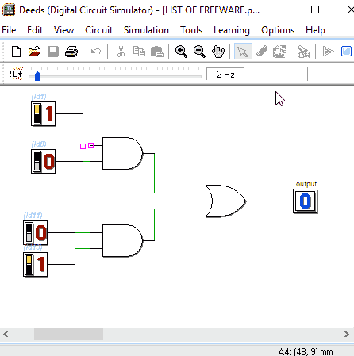

Figure 1 diagram showing a design of a logic gate simulator system.

**2.2 Types of logic gate simulator systems**

We have 3 basic types of logic gate simulator systems which includes:

1. **Digital Logic Gate Simulator**: A digital logic gate simulator is a software program that allows users to design and simulate digital logic circuits. It typically includes a library of logic gates, such as AND, OR, NOT, NAND, NOR, XOR and XNOR gates. The user can then connect these gates together to create more complex circuits.

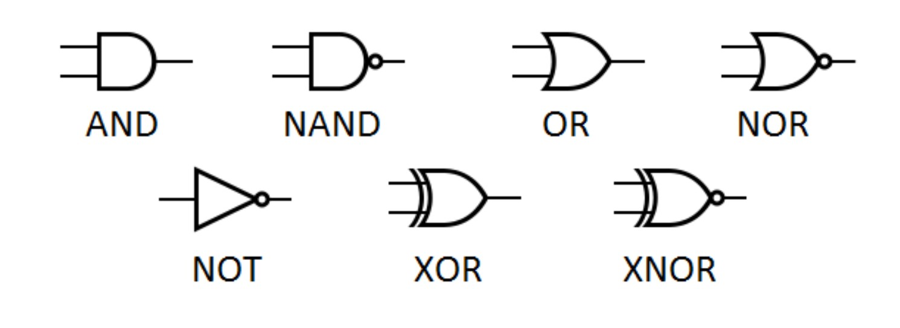

Figure 2 diagram showing the different types of digital logic gates.

1. **Analog Logic Gate Simulator**: An analog logic gate simulator is a software program that allows users to design and simulate analog logic circuits. It typically includes a library of analog components such as resistors, capacitors and transistors. The user can then connect these components together to create more complex circuits.
2. **Programmable Logic Gate Simulator**: A programmable logic gate simulator is a software program that allows users to design and simulate programmable logic circuits. It typically includes a library of programmable logic devices such as FPGAs (Field Programmable Gate Arrays) and CPLDs (Complex Programmable Logic Devices). The user can then connect these devices together to create more complex circuits.

**2.3 Examples of logic gate simulator systems**

Here are 4 examples of logic gate simulator systems which includes:

1. **Logisim:** Thisis an educational tool for designing and simulating digital logic circuits. With its simple toolbar interface and simulation of circuits as you build them, it is simple enough to facilitate learning the most basic concepts related to logic circuits**.** [3]

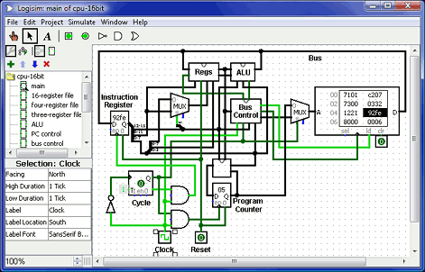

Figure 3 Screen shot of Logisim 2.7.0

1. 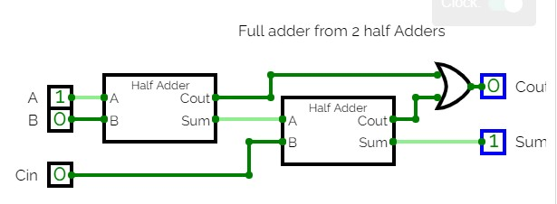**CircuitVerse:** CircuitVerse is an online logic gate simulator system that allows users to design, simulate, and share their own digital circuits. It features a modern web-based interface with drag-and-drop components, and supports both combinational and sequential logic.

Figure 4 Screen shot of CircuitVerse

1. **Logicly:** Logicly is a paid logic gate simulator system that allows users to design, simulate, and debug digital circuits. It features an intuitive graphical user interface with drag-and-drop components, and supports both combinational and sequential logic.

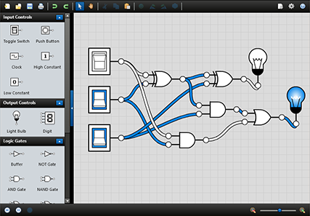

Figure 4 Screen shot of Logicly 1.13.0

1. **Falstad Circuit Simulator:** Falstad Circuit Simulator is a free online logic gate simulator system that allows users to design, simulate, and share their own digital circuits. It features an intuitive graphical user interface with drag-and-drop components, and supports both combinational and sequential logic.

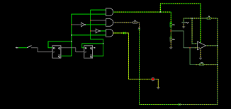

Figure 5 Screen shot of Falstad Circuit Simulator

**SECTION THREE: IMPORTANCE, USES APPLICATIONS, ADVANTAGES AND DISADVANTAGES OF LOGIC GATE SIMULATOR SYSTEMS.**

**3.1 Importance of logic gate simulator systems.**

Logic gate simulator systems are important for a variety of reasons.

1. They allow engineers and students to design, test, and debug digital circuits without the need for physical components.
2. They also save time and money in the development process, as well as reduce the risk of errors due to incorrect wiring or component selection.
3. They also give a visual representation and behavior of a circuit before it’s been implemented using the real items.
4. They also have a variety of components in their library which gives an engineer multiple options to choose from while designing a circuit.
5. Finally, it also has a good feedback system which tells the engineer if the component used in designing a circuit is actually compactible with the system.
   1. **Uses of logic gate simulator systems.**

Logic gate simulator systems is used and is applied in different areas

1. Logic gate simulators are used to teach students the fundamentals of digital logic and computer engineering. By providing a virtual environment for students to explore and experiment with, they can gain a better understanding of the principles behind digital logic and computer engineering.
2. Logic gate simulators are used to develop and test new designs for digital circuits. By providing a virtual environment for engineers to design, simulate, and debug their designs, they can quickly identify any potential problems before committing to physical implementation.
3. Logic gate simulators are used in the development of embedded systems such as microcontrollers and FPGAs (Field Programmable Gate Arrays). By providing a virtual environment for engineers to design, simulate, and debug their designs, they can quickly identify any potential problems before committing to physical implementation.
4. Logic gate simulators are also useful tools for troubleshooting existing digital circuits. By using simulation software, engineers can analyze existing circuits without having access them physically. This allows them diagnose issues more efficiently without having access them physically.
5. Logic gate simulators are used in the development of communication networks such as cellular networks or Wi-Fi networks. By providing a virtual environment for engineers to design, simulate, and debug their designs, they can quickly identify any potential problems before committing to physical implementation.
6. Logic gate simulators are used in the development of aerospace systems such as aircraft navigation systems or satellite communication networks. By providing a virtual environment for engineers to design, simulate, and debug their designs, they can quickly identify any potential problems before committing to physical implementation.
7. Finally, these systems can be used to simulate complex systems that would otherwise be too expensive or difficult to build in the real world.
   1. **Applications of logic gate simulator systems**

Logic gate simulator systems are applied in the development of:

1. NAND Gates which are used in Burglar alarms and buzzers.
2. Push buttons which are used in the creation of switches.
3. AND Gates which are used to enable the data transfer function.
4. TTL (Transistor Transistor Logic) and CMOS circuitry.
5. Circuits which involves computation and processing.

**SECTION FOUR: CONCLUSION**

References:

[1] Steve Kollmansberger, “- Logic Gates Simulator” in *kolls.net/gatesim,* united states, 2009.

[2] Frank AI, in *frankai.netlify.app,* 2022

[3] “- Logisim” in  *cburch.com/logisim,* 2014.

[4] [Laxmi Ashrit](https://electricalfundablog.com/author/laxmi-ashrit/), “-Logic Gates – Types, Working Principle, Application, Advantage” in *electricalfundablog.com/logic-gates-types-working-principle,* 2022